Some JavaScript functions create instances not only when *invoked as constructors*, but also when *invoked as functions*.

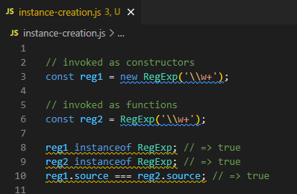

Using function invocation to create objects

* Potential problem (excluding factory pattern)
* Some constructors may omit the logic to INITIALIZE the object when the ‘new’ keyword is missing

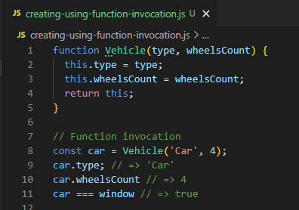

‘this’ is *window* object in a function invocation

* Vehicle('Car', 4) sets properties on the window object. This is a mistake. A new object is not created.

Make sure to use new operator in cases when a constructor call is expected:

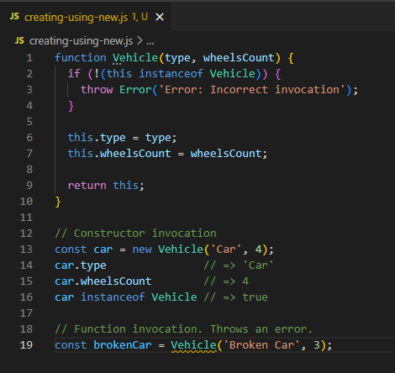

<obj> instanceof <constructor>

* For verification if the obj is an instance of the constructor